ECE 441 Fall 2021

WEEK #4 GROUP MEETING LOG

Lab Session: 2

Group Number: 2

Instructor: Dr. Jafar Saniie

Due Date: 02-09-2022

Acknowledgment: I acknowledge all of the work (including figures and codes) belongs to me and/or persons who are referenced.

Member 1: Alan Palayil

Member 2: Fabian Garcia

Member 3: Gabriel Gutierrez

[Smart Mirror - *Through the Speculum*]

**Project Goal:**

* Create a smart mirror with gesture control and face recognition.
* Include accessories like LED strips and a sound system.

**Standards used in Project:**

Not applicable during this stage of the project

**System Constraints:**

Budget

**Prior Knowledge Acquired Critical to Design Project:**

ECE 100, ECE 211, ECE 213, ECE 218, ECE 242, ECE 307, ECE 308, ECE 311, ECE 319, ECE 407, ECE 411, ECE 436, ECE 438, ECE 485, CS 115, CS 116, CS 330, CS 331, CS 350, CS 351, CS 450

Note: CS 331- Data Structures and Algorithms (Python Programming)

Meeting 1

| Date | 2/5/2022 |
| --- | --- |
| Start Time | 12:00 PM |
| Duration | 2 hours |
| Attendance | All attended |

1. **Agenda**

The purpose of this meeting was primarily to get our ideas in order and see where to go from here. We did a self-inventory check and talked about our possible limitations going forward.

Fabian/Gabriel:

Gesture Control:

If we are provided with a Raspberry Pi 1 or 2 we must use the Kinect v1. ([link](https://github.com/alwynmathew/Gesture-control-IoT-devices)) Research for working with the sensors of Kinect. ([link](https://forums.raspberrypi.com/viewtopic.php?t=156543))

Gesture controls ([link](https://github.com/Kazhunter/General-gesture-recognition-system-using-kinect-and-raspberry-pi))

Alan:

Voice Assistant:

Using our own Raspberry Pi, we have compiled the program for both Alexa and Google Assistant. ([link](https://github.com/AlanP13/SmartMirrorPi))

Mirror Interface:

Researched on the various options which are possible to add the mirror interface. The most prominent one being Magic mirror which is an open-source base on which we can customize our Smart Mirror. ([link](https://magicmirror.builders))

**Items that are readily available that we have:**

**Fabian**

**Self-inventory:**

-Raspberry Pi

-24” Computer Monitor

-Arduino UNO

**Gabriel**

**Self-inventory:**

* Arduino Mega 2560
* 24 LED TV

**Alan**

**Self-inventory:**

* Raspberry Pi 4 (8 GB) (with Power Supply)
* HDMI cable
* Bluetooth 5 Speakers (AUX cable): ([link](https://www.amazon.com/Anker-Soundcore-Bluetooth-Exclusive-Water-Resistant/dp/B01MTB55WH/ref=sr_1_5?crid=1VJ64W617CEJS&keywords=anker+speaker&qid=1644088718&s=electronics&sprefix=anker+speaker+%2Celectronics%2C86&sr=1-5))
* Addressable LED strip 16Ft (Don’t have the power supply): ([link](https://www.amazon.com/gp/product/B088BB8WTZ/ref=ox_sc_saved_title_3?smid=A35UAT07QG3EC6&psc=1))

**FINALIZED COMPONENT LIST:**

1. **Raspberry Pi 4 and Raspberry Pi Zero**
2. **For user input: (a) XBox Kinect** [**(link)**](https://www.gamestop.com/gaming-accessories/controllers/xbox-one/products/microsoft-kinect-for-xbox-one/102581.html?gclid=Cj0KCQiA3fiPBhCCARIsAFQ8QzXYEH2re1BVw5nMAqDBVqxpR9S-05hy4om79O2z1N74s-H0ePArvjEaAnSFEALw_wcB&gclsrc=aw.ds) **and Kinect USB adapter (**[**link**](https://www.amazon.com/Adapter-Xbox-One-Windows-Certified-Updated/dp/B07JHJM9FG/ref=sr_1_3?keywords=kinect+adapter&qid=1644089351&sprefix=kinect+%2Caps%2C88&sr=8-3)**)**

**(b) IR Frame with Camera and PIR sensor**

1. **IPS Monitor (either complete or just the panel)**
2. **Pre-cut acrylic two-way mirror** [**(link)**](https://www.amazon.com/0-04-Acrylic-See-Through-Mirror-Transparent/dp/B01CZ35XWY?th=1)
3. **Addressable LED Strips**
4. **Speakers**
5. **Microphone**
6. **HDMI cable**

1. **Tasks**

| **1 - Idea development** | | |
| --- | --- | --- |
| **Task** | **Assigned to** | **Due Date** |
| Begin Working on Project Proposal | Team | 2/24 |
| Email TA about proposal | Gabriel | Before Next Meeting |
| Look into Gesture Controls | Team | Before Next Meeting |
| Raspbian and XBox One Kinect Integration | Fabian | Before Next Meeting |
| Ask about available items/budget | Team | 2/24 |

1. **Work Distribution**

| **Alan Palayil** | Explore the custom widgets on the mirror interface and work on the ambient light. Also look into Kinect sensors and cameras to work with the Pi. |
| --- | --- |
| **Fabian Garcia** | Looked into gesture control and gathered some materials. Look into the integration of XBox Kinect with Raspberry and alternate controls for gesture controls. |
| **Gabriel Gutierrez** | Looked into a different version of the Kinect gesture integration. And reached out to the TA. |

1. **Progress and Milestones**

We finalized our parts list and checked off everything that we already have at our disposal. A rough estimate of the cost for the current parts that we need was also done.

1. **Next Steps**

Wait for the TA response on our resources and our next steps. We will also look more into gesture control since this will require the most work from our team. We will be meeting Monday the 7th.

Meeting 2

| Date | 2/7/2022 |
| --- | --- |
| Start Time | 1:00 PM |
| Duration | 2 hours |
| Attendance | All attended |

1. **Agenda**

* Finalize component list and discuss the email
* Need vs want
* Discuss project proposal

**Resources available to us:**

**IIT’s lab equipment:**

* Oscilloscope, function generator, multimeter, power supply, soldering station, 3D printer, + more

**Software help:**

* TAs and members of ECASP lab
* Familiar with AI and deep learning
* Can suggest libraries and databases

**ECE department:**

* Will cover projects within a few hundred dollars (Note: Will not reimburse our own purchases)

**Research:**

**Fabian**

Kinect V2 is only compatible with USB 3.0 devices. The depth camera of the XBox One Kinect. The amount of raw data is too large for a USB 2.0 device to process. Due to this anything below a Raspberry Pi 4 would not function properly. For the Kinect V1, any Raspberry Pi would suffice because the Kinect is a standard USB 2.0 connection. Since we are using the Kinect V2, we will continue with a Raspberry Pi 4. In order to allow the use of the Kinect, we must use freenect2.0. [(Link)](https://github.com/OpenKinect/libfreenect2)

This forum discusses some issues with the implementation of freenect2.0 and the Raspberry Pi 4. It includes some fixes and additional information.([Link](http://blog.bitcollectors.com/adam/2016/01/kinect-support-for-raspberry-pi-using-libfreenect/%20https://github.com/OpenKinect/libfreenect2))

* Creating own gestures with Kinect: ([Link](https://medium.com/@sunx0578/gesture-commands-with-kinect-gesture-recognition-143a605150e6))
* Record, Analyze, and Implementation process shown.
* Would need to install the SDK for Linux rather than Windows

**Gabriel**

Depending on the method used, OpenCV must be installed. This [link](https://circuitdigest.com/microcontroller-projects/hand-gesture-recognition-using-raspberry-pi-and-opencv) provides an example of gesture recognition by playing rock, paper, scissors.

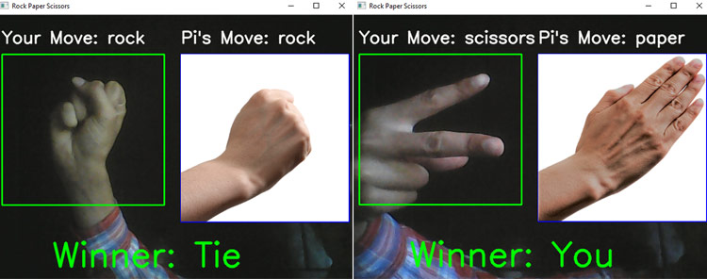Source: circuitdigest

It includes:

* Data gathering,
* Training model
* Gesture Detection.

We can repurpose this code to execute both commands and programs depending on what our project’s purpose is. However, this method would not implement the Xbox Kinect’s IR sensor.

**Alan**

Started working on the display interface for the Smart mirror. Researching on all the possible widgets needed and integration of the camera module to have face recognition and gestures.

Started looking into the light integration to create an ambient light around the lights. Considering that we build on the Hyperion API to integrate the lights to run with the interface. The issue as of yet is that the hyperion is on OS which means that we’ll need to look over adding a raspberry pi zero to the set-up to enable ambient light setting.

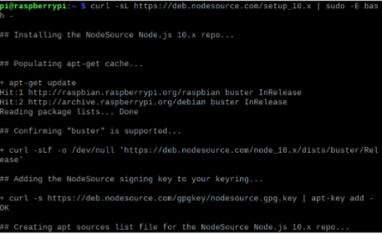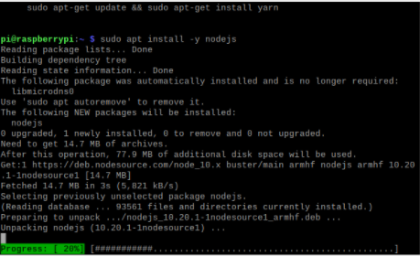

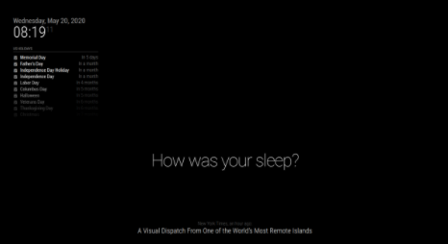

1. **Tasks**

| **1 - Idea development** | | |
| --- | --- | --- |
| **Task** | **Assigned to** | **Due Date** |
| Obtain Information on Current Display | Fabian | 2/12/2022 |
| Look into IPS panels | Alan | 2/12/2022 |
| Finalize Component List and Submit | Team | 2/12/2022 |
| Ask about available items/budget | Team | 2/12/2022 |
| Beginning formatting and typing the proposal | Team | 2/24/2022 |

1. **Work Distribution**

| **Alan Palayil** | Look into ambient light integration with the Smart mirror. Work on the Mirror interface and look over the final components to be used. |
| --- | --- |
| **Fabian Garcia** | Looked into Kinect integration and creating personalized gestures. Will obtain information on the current display that we have and will finalize the component list alongside the rest of the team. |
| **Gabriel Gutierrez** | Looked into basic gesture control involving a camera. Began the component list sheet which will be finalized by the team. |

1. **Progress and Milestones**

We acquired more information on gesture control, more specifically, how to record our own gestures and how to use OpenCV with a camera for gestures. We have also made two separate parts lists for 2 separate methods of approach for the final design of the Smart Mirror.

1. **Next Steps**

Our next meeting will be on February 12 at noon.

We will finalize both parts lists and submit one for review so we can see how viable that option is. If one fails, or the parts are difficult to obtain, we will pursue the other smart mirror design. We will obtain a Raspberry Pi 4 from the ECE department and begin testing.